- Run basic prolog programs for family try
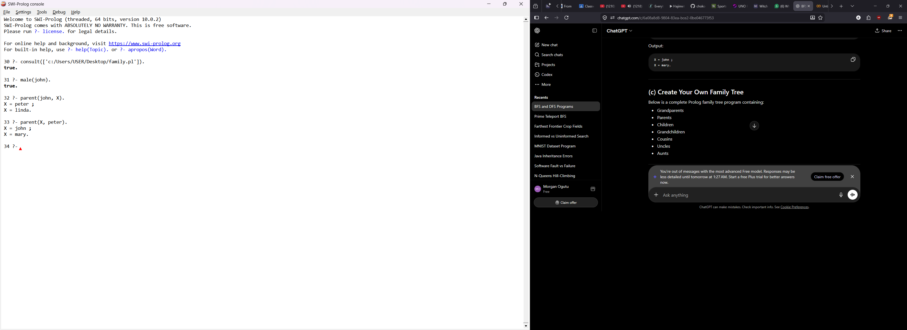

- Create your own family tree – contains: grandparents, parents, children, grandchildren, cousins, uncles and aunts.

